**Information for Patients: Medication Abortion**

Today you decided to have a medication abortion, which is very safe and works almost all of the time.

**The first pill is called mifepristone (Mifeprex® or generic equivalent)**. To begin the process:

___You took 200 milligrams of mifepristone in the office at________am/pm OR

___You will take 200 milligrams mifepristone at home on ______ at _____am/pm. (Pill should be swallowed with water.)

Most people do not feel any different after taking mifepristone. You may have some vaginal bleeding, which is okay. You can continue all of your regular activities.

**The second set of pills are called misoprostol.** Each misoprostol pill is 200 micrograms.

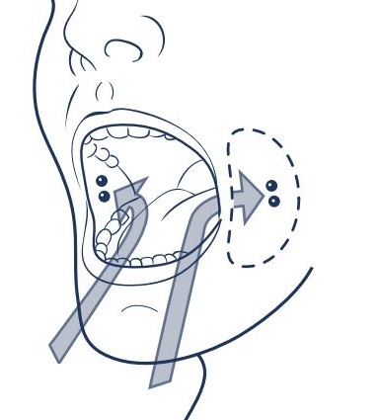

On,__________, at around________am/pm, you will put 4 misoprostol pills inside your cheeks as we have shown you. You should use these pills even if you have already started to bleed. After putting two pills in each cheek, let them melt/dissolve for 20‒30 minutes. (You can swallow saliva but it’s better not to swallow the pills.) This lets the medicine slowly get into your body. If any of the pills are left in your mouth after 20‒30 minutes, you can swallow them with water.

We have also given you prescriptions for the **pain medicines** **ibuprofen and hydrocodone/acetaminophen.** You can take 2 ibuprofen pills (800mg total) 30 minutes before you put the misoprostol pills inside your cheeks; this may help reduce side effects.

**Symptoms to Expect:**

After taking the misoprostol, you may feel nauseated, have diarrhea, or vomit. This is common for this medicine. Misoprostol causes cramping and bleeding, often with clots. This may be more than you normally have with your period. It is a good idea to use a pad in case you start bleeding right away. The bleeding and cramps usually start 1 to 4 hours after you take the misoprostol, and often last for as much as 6 hours. Although you may have a lot of bleeding, this is okay; this means that the medication is working. The bleeding is usually heavy for the first few hours and then gets lighter. Bleeding or spotting may last for several weeks, and it may stop and start several times.

If you are having a lot of pain or cramps, you can take more ibuprofen or take 1 or 2 of the hydrocodone/acetaminophen pills. (Otherwise you can flush them down the toilet.) Ibuprofen and hydrocodone/acetaminophen are different types of medication, and it is okay to take them together. You can also use a heating pad, or drink some warm tea or soup, to relieve the cramps or pain.

**If you have questions or concerns:**

You can call the 24-hour phone:_________________; leave a message with your number and a doctor will call you back. Call us if:

* *You do not bleed at all after 24 hours of taking the second medication (misoprostol)*
* *You are soaking more than 4 maxi pads in 2 hours*
* *Your pain is not better after using the medicines*
* *You have a fever over 100.4 F*
* *You get strong stomach pain or feel really sick more than 24 hours after using the misoprostol*

If you have other questions, are worried or scared, have heard different information from somewhere else, think something is going wrong or that you have an emergency, please call us.

*(Please try again if your call does not go through the first time or if we do not call you back within a half hour.)*

**How do I know that the abortion worked?**

Most people have cramps and bleeding after they take the medication, although some people do not have very heavy bleeding and that is okay. Many people know the abortion worked because they no longer feel pregnant. A pregnancy test will stay positive for a few weeks even though you will no longer be pregnant.

**Follow-up:**

Medication abortion is very safe and effective, and you can choose how you want to follow up with us. If you want a follow-up appointment, you can make that today. Or you can schedule a follow-up phone call. You can always reach us using the phone number above.

If you want to start birth control, you can begin using the method on the date we decided, even if you are bleeding. It is safe to go back to your regular activities as soon as you want. You can have sex and/or use tampons whenever you feel ready. You can take a shower or bath as soon as you want to. You can eat normally, although you may still feel nauseated for another few days because of pregnancy hormones.